FIRE RESISTANT BUILDING MATERIALS

Comprehending how a fire will behave in and around a building starts with understanding the stages in the development of a fire. Being familiar with the terminology used helps to interpret the subsequent fire performance ratings given to building materials and aids correct specification.

​

**Reaction to fire**

In the early stages of a fire, it is the 'reaction to fire' properties of the various individual materials exposed to flame that are the critical factors:

**Ignitability** – how readily will a material ignite and catch fire?

**Spread of flame** – once ignited, how quickly will flames spread across the surface of that material?

**Heat release** – once alight, how much heat energy will be generated by the burning material, which will contribute to the further growth of the fire?

**Flaming droplets** – will the burning material disintegrate and produce burning droplets or debris which might fall onto and ignite other surfaces?

**Resistance to Fire**

Once the fire is more developed, then containment becomes the top priority with the use of compartmentalisation as a common strategy in buildings. At this stage, it is the 'fire resistance' ratings of the building structure and its design elements such as walls, floors and fire doors that become the critical factors.

*'Reaction to fire' classifications are completely different to 'resistance to fire' ratings yet the two terms are often misunderstood and taken to mean the same thing.*

The key differences:

​

**Reaction to fire** is the measurement of how a material will contribute to the fire development and spread, particularly in the very early stages of a fire when evacuation is crucial.

​

**Fire resistance** is the measurement of the ability of a building/construction element to resist, and ideally prevent, the passage of fire from one distinct area/building compartment to another.

**Combustibility**

Another term which is misunderstood and misused but is commonly referred to within fire performance ratings is 'combustibility'. The official definition used in EN standards and building regulations is as follows:

​

*For a material to be classed as either non-combustible or of limited combustibility it must achieve Class A1 or A2 in testing (*[*see table below)*](https://www.thewpa.org.uk/flame-retardants)*. A limited lateral spread of flame classification does not infer any resistance to combustibility, it is solely a measure of the rate of spread of a flame across the surface under defined conditions.*

​

Using this classification system, any material rated Euroclass B or lower is therefore classed as combustible, albeit to varying degrees.

Untreated wood-based materials normally have a Euroclass D or E rating.

Depending on the system and loading used,this may be enhanced to Class B or C by the addition of a flame retardant.

​

Data obtained from **reaction to fire** testing, results in that material being given a **Euroclass** performance rating.  Almost all fire testing carried out in the UK today is to Euroclass (EN 13501-1) reaction to fire performance criteria.

The Euroclass system also includes classification categories for *smoke production* (class s1 to s3) and *creation of flaming droplets* (class d0 to d2).

​

NOTE: The *resistance to fire* rating of a building element (in accordance with EN 13501-2), is normally expressed in ‘minutes of fire containment’ (e.g. a fire door with a 30-minute fire resistance rating).

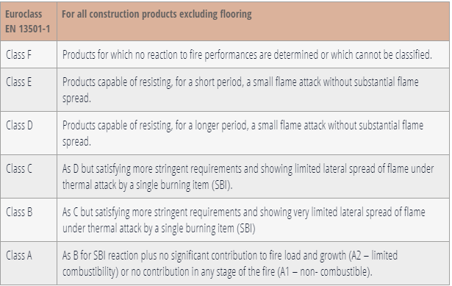

Once you have established the [**Euroclass**](https://www.thewpa.org.uk/flame-retardants) rating required of your project material, you also have to consider where and how it is being used in order to specify the appropriate treatment. Three **service classes** are defined in the structural design code BS EN 1995-1-1.

To correspond with these codes, the WPA categorises flame retardant products into three **types**:

​

**INT1**   (formerly **DI**: Dry Interior) for dry interior applications

**INT2**(formerly **HR**: Humidity Resistant)for humid interior or fully covered exterior applications

**EXT**(formerly **LR**: Leach Resistant) for all interior and exterior applications.

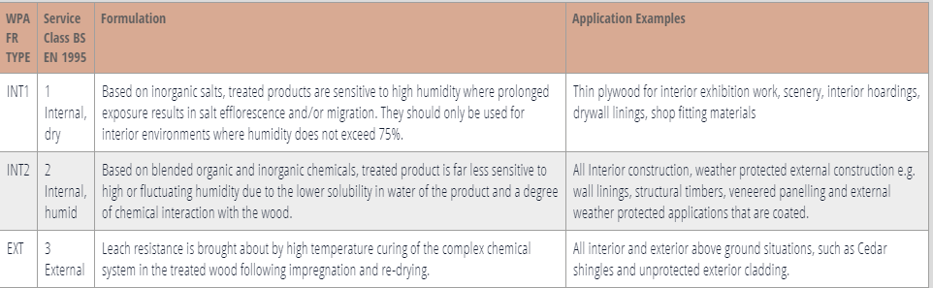

​

Specify the Fundamentals

What fire performance is required - Euroclass B or C?

What is the service environment / treatment type?

Internal dry (INT 1)

Internal humid (INT 2)

or External (EXT)

**Specify a named product if desired.**

**Whilst it is not possible to enhance any organic substrate, including wood-based materials, to a Class A rating, flame retardant treated wood-based materials enhance safety, add value and are fit for purpose for many many applications and in compliance with Building Regulations.**

In terms of specifying a flame retardant treatment or wood-based flame retardant treated product it is vital to verify the product’s **performance credentials** – ie: what fire performance properties are claimed by the manufacturer? All performance claims should be independently verified and reflect the performance required.

The most widely used process for treating both solid wood components and panel products with flame retardants is vacuum-pressure impregnation. This is carried out by specialist companies in large pressure autoclaves under factory controlled conditions.

For panel products such as OSB particle board, plywood and medium density fibreboard (MDF) a WPA approved flame retardant can be incorporated as an integral part of their manufacture.

Formulations for surface application are only approved by the WPA when they are applied in a factory under third-party quality assured processes to achieve the performance set out in fire test Classification Reports.

​

**The application of flame retardant products on the construction site, by brush or spray is NOT APPROVED by the WPA as quality control is almost impossible to assure**.

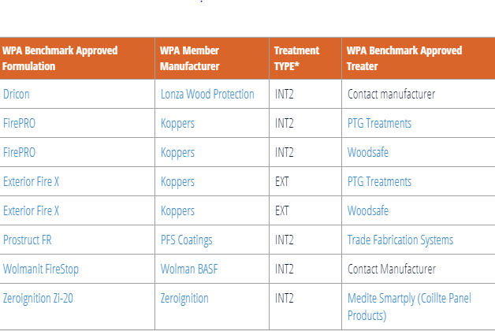

<https://www.intechopen.com/books/new-technologies-in-protective-coatings/fire-retardant-coatings>

Classification according to European Standard EN-13501-1

|  |  |  |  |
| --- | --- | --- | --- |
| Non-combustible materials | A1 | | |
| A2 – s1 d0 A2 – s2 d0 A2 – s3 d0 | A2 – s1 d1 A2 – s2 d1 A2 – s3 d1 | A2 – s1 d2 A2 – s2 d2 A2 – s3 d2 |
| Combustible materials: Very limited contribution to fire | B – s1 d0 B – s2 d0 B – s3 d0 | B – s1 d1 B – s2 d1 B – s3 d1 | B – s1 d2 B – s2 d2 B – s3 d2 |
| Combustible materials: Limited contribution to fire | C – s1 d0 C – s2 d0 C – s3 d0 | C – s1 d1 C – s2 d1 C – s3 d1 | C – s1 d2 C – s2 d2 C – s3 d2 |
| Combustible materials: Medium contribution to fire | D – s1 d0 D – s2 d0 D – s3 d0 | D – s1 d1 D – s2 d1 D – s3 d1 | D – s1 d2 D – s2 d2 D – s3 d2 |
| Combustible materials: Highly contribution to fire | E | E – d2 | |
| Combustible materials: Easily flammable | F | | |

The European classifications break down into codes, the ‘d’ part relates to ‘**flaming droplets and particles**’ during the first 10 minutes of exposure. The index is:

D0 = none  
D1 = some  
D2 = quite a lot

The ‘**s**’ part relates to total **smoke propagation**, during the first ten minutes of exposure. These determine a ‘smoke’ index:

S1 = a little or no smoke  
S2 = quite a lot of smoke  
S3 = substantial smoke

|  |  |  |  |
| --- | --- | --- | --- |
| Also additional data on  Smoke emission during combustion | s | 1 2 3 | A little or no smoke Quite a lot of smoke Substantial smoke |
| Production of flaming droplets/particles during combustion | d | 0 1 2 | None Some Quite a lot |

British Standards

As a further guide to the British standards (BS) on cladding fire testing, please see below how the older BS classifications compare to the more recent European classifications.

These were based on tests for burning materials and structures governed by BS 476. This breaks down into two parts relevant to cladding:

**Part 7** – surface spread of flame, which measures the spread and extent that a flame would travel across the surface of the material and;

**Part 6** – fire propagation, which measures the actual contribution made by the component assembly to the growth of the fire.

|  |  |
| --- | --- |
| British Standard | Transposition to Euro Class |
| Non-combustible | A1 |
| Limited Combustibility | A2–s3,d2 (or better) |
| Class 0 | B-s3,d2 (or better) |
| Class 1 | C-s3,d2 (or better) |
| Class 3 | D-s3,d2 (or better) |

https://www.vivalda.co.uk/products/decorative-cladding/fire-rating/

Fire rating by cladding

EUROPEAN STANDARD EN-13501-1

[Trespa](https://www.vivalda.co.uk/products/decorative-cladding/fire-rating/#trespa)

|  |  |  |
| --- | --- | --- |
| **Product** | **Std** | **FR** |
| Trespa Meteon | D-s2,d0 | B-s1,d0* |
| Trespa Pura NFC |  | B-s2,d0 |
| Trespa TopLab Base | D-s2,d0 | B-s2,d0* |
| Trespa TopLab Vertical | D-s2,d0 | B-s2,d0* |
| *\*If panel thickness is equal to or greater than 8mm and used with a metal frame* |  |  |

[Marley Eternit](https://www.vivalda.co.uk/products/decorative-cladding/fire-rating/#marley-eternit)

|  |  |
| --- | --- |
| **Product** | **Std** |
| EQUITONE | A2-s1,d0 |
| Cedral Weatherboard | A2-s1,d0 |
| Cedral Click | A2-s1,d0 |

[Parklex](https://www.vivalda.co.uk/products/decorative-cladding/fire-rating/#parklex)

|  |  |  |
| --- | --- | --- |
| **Product** | **S** | **F** |
| Parklex | C-s1,d0 | B-s1,d0 |

[Rockpanel](https://www.vivalda.co.uk/products/decorative-cladding/fire-rating/#rockpanel)

|  |  |  |
| --- | --- | --- |
| **Product** | **Std** | **FS-Xtra** |
| Rockpanel range | B-s2,d0 | A2-s1,d0 |
| Rockpanel Natural | B-s2,d0 |  |
| Rockpanel Ply | B-s2,d0 |  |
| Rockpanel Lines | B-s2,d0 |  |
| *Aluminium or Steel sub-construction When fixed with blind rivets and application of premium FS-Xtra boards, in combination with mineral wool insulation, this meets the requirements for A2-s1,d0.* |  |  |

[Formica](https://www.vivalda.co.uk/products/decorative-cladding/fire-rating/#formica)

|  |  |  |
| --- | --- | --- |
| **Product** | **Std** | **FR** |
| VIVIX | D-s2,d0 | B-s1-d0 |
|  |  |  |

[Cembrit](https://www.vivalda.co.uk/products/decorative-cladding/fire-rating/#cembrit)

|  |  |
| --- | --- |
| **Product** | **Std** |
| Solid | A2-s1,d0 |
| Patina / Cembonit | A2-s1,d0 |
| Cover | A2-s1,d0 |
| Transparent | A2-s1,d0 |

[FunderMax](https://www.vivalda.co.uk/products/decorative-cladding/fire-rating/#fundermax)

|  |  |
| --- | --- |
| **Product** | **Std** |
| Max Exterior F Quality | B-s2,d0 |

[Werzalit](https://www.vivalda.co.uk/products/decorative-cladding/fire-rating/#werzalit)

|  |  |  |
| --- | --- | --- |
| **Product** | **Std** | **FR** |
| Selekta | D-s2,d2 | B-s3,d0 |
| Siding | D-s2,d2 | B-s3,d0 |
| Square | D-s2,d0 | B-s2,d0 |

[Prodema](https://www.vivalda.co.uk/products/decorative-cladding/fire-rating/#prodema)

|  |  |  |
| --- | --- | --- |
| **Product** | **Std** | **IGN** |
| ProdEX | C-s1,d0 | B-s1,d0 |